

Project Name: BuildMart

Branch PG-DAC Sep-2023

Documentation On

**“BuildMart”**

PG-DAC September 2023

**Guided By: Dipali Jadhav**

Submitted By :

**Group No: 05**

* **Dhiraj Babasaheb Nagargoje 230943020027**
* **Gajanan Dnyandev Shinde 230943020030**
* **Rushikesh Jagdish Nikam 230943020061**
* **Suyash Sanjay Bhonde 230943020098**

**Table of Contents**

**1. Introduction 3**

**2. Business Requirements Overview 4**

**3. Functional Requirements Overview 6**

**4.Non Functional Requirements Overview 7**

**5. Use Case Diagram 8**

5.1 Individual Customer **8**

5.2 Construction Material Vendor **9**

5.3 Service Provider **10**

5.4 Construction Company **11**

5.5 Admin **12**

**6. Database Design 13**

**7. ER Diagram 15**

**8. Page Navigation Diagrams 18**

**9. Snapshots 23**

**10. Conclusion 23**

**List of Figures**

Fig 1 Individual Customer **8**

Fig 2 Construction Material Vendor **9**

Fig 3 Service Provider **10**

Fig 4 Construction Company **11**

Fig 5 Admin **12**

Fig 6 Er Diagram **17**

Fig 7 Page Navigation For Individual Customer **18**

Fig 8 Page Navigation For Construction Material Vendor **19**

Fig 9 Page Navigation For Service Provider **20**

Fig 10 Page Navigation Construction Company **21**

Fig 11 Page Navigation For Admin **22**

# Introduction

#### Document Purpose

This document communicates the business requirements and scope for developing BuildMart (ecommerce for construction materials) System. The scope of this document is to define the functional and non-functional requirements, business rules and other constraints requirements.

#### Project Background

There is no computerized system for the vendors and service providers to sell their construction materials and provide services. The traditional system of purchasing construction equipment has certain limitations or faults compared to e-commerce.

Here are some common faults associated with the traditional system:

* + - Limited Access
    - Limited Product Information
    - Lack of Price Transparency
    - Inconvenience for Comparison Shopping

#### Goals of the project

To develop and deploy a comprehensive e-commerce platform for construction materials that caters to the needs of Individual customers, construction material vendor, and service providers, creating a thriving marketplace that facilitates seamless interactions and transactions within the construction industry.

To solve the problems in traditional system and provide all the services at one place so that customer can easily avail the services

#### Customers and Stakeholders

##### Customers :

##### Stakeholders :

* Construction material vendors who want to sell their materials.
* Construction related work service providers who want to provide their services.
* Individual customers want to buy the materials and services.
* Construction companies want to buy materials and services in large scale.
* Individual Customers
* Construction Community
* Construction material vendors
* Construction workers Organization
* Traditional Retailers and Physical Stores
* Transportation service providers

## Business Requirements Overview

* BuildMart System is the public web application.
* BuildMart System will be opened to the global, but in the phase 1, the main target is in the India.
* There are mainly four types of user.
  1. Construction material vendors
  2. Individual Customers
  3. Construction companies
  4. Service providers
* Customers and construction companies can search for the market values of required construction materials.
* Construction companies can get projects from customers.
* Wholesale suppliers can sell their materials, can get orders from customers and construction companies.
* Service providers can communicate with customers for providing services.
* BuildMart System provides the functions which connect the customers and the wholesaler efficiently.
* BuildMart System could be maintained by Administrator.

## Functional Requirements Overview

BuildMart System consists of Five modules described as below.

1. Individual Customers Module
2. Construction material vendors Module
3. Service providers Module
4. Construction companies Module
5. Admin Module

#### Individual Customer Module

* Customers can register and create his own account.
* BuildMart System provides the function which allows customers to buy construction materials.
* He is able to browse existing Market price of various materials.
* The customers can learn the technique how to use BuildMart.
* The customers can compare prices of materials for various brands.
* Customers can search for service providers for their work.
* Customer can give rating to Vendors and service providers.

#### Construction material vendor Module

* Vendor can register and create his own account.
* Vendor can add list of materials available with details to their account.
* Vendor can update the stock of materials and prices.

#### Service provider Module

* Service provider can register and create his own account.
* Service provider can list type of services they provide along with details.
* Service provider can update their profile.
* Service provider can add information about their previously completed projects.

#### Construction company Module

* Construction company can register and login
* Construction company can buy materials for their construction sites.
* Construction company have to buy our prime membership.
* Construction company can get services from Service Providers.

#### Admin Module

* BuildMart System should provide all function to admin how to handle the System.
* Admin can update stocks of various materials.
* Admin can create report of received and processed orders.
* Admin can manage premium membership and also provide offers and discounts.

## Non-functional Requirements

* The website should use professional design, look and feel and color scheme.
* Users will have no limitations for accessing the application through Internet. The portal being an internet application, it is difficult specify exact number of visitor or users. Hence we will target the system to support between 5 and 10 million users on launch of phase 1.
* Being a public website, the site must follow general usability guidelines for menus, navigation, colors, links and other actions provided on the screens.
* The system should be designed in such a manner that user will be able to complete tasks in minimum number of steps.

# Use Case Diagram

## 

## 5.1 Individual Customer:

Register

Login

Search

Product

Add To Cart And View Cart

Place Order

View Order

History

View Payment

History

Individual Customer

*Fig. Use case diagram for Individual Customer*

**5.2 Construction Material Vendor:**

Construction Material Vendor

Register

Login

Add and Delete

Product

Update Quantity and Rates

View Order

History

View Payment

History

Launch

Offers

*Fig. Use case diagram for Construction Material Vendor*

**5.3 Service Provider:**

Register

Login

Update Availability

Status

Update Rates

Service Provider

Fig. Use case diagram for Labour

**5.4 Construction Company:**

Construction Company

Register

Login

Search

Product

Add To Cart And View Cart

Place Order

View Order

History

View Payment

History

Fig. Use case diagram for Construction Material Vendor

**5.5 Admin:**

Login

Report

Generation

Account Management

Membership

Management

Maintain Labour

Status

Admin

Fig. Use case diagram for admin

6. Database Design :-

**1.Users Table**

|  |  |  |  |  |  |
| --- | --- | --- | --- | --- | --- |
| Users Table | | | | | |
| Field | Type | Null | Key | Default | Description |
| id | Integer | No | Primary key | Null | Login Id |
| User_name | Varchar(255) | No |  | Null | User name |
| password | Varchar(255) | No |  | Null | Account Password |
| roleid | Integer | No | Foreign key | Null | Reference to Role (Roleid) |
| status | Varchar(255) | No |  | Null | Status of User Registration |

**2.Construction company Table**

|  |  |  |  |  |  |
| --- | --- | --- | --- | --- | --- |
| Construction company Table | | | | | |
| Field | Type | Null | Key | Default | Description |
| id | Integer | No | Primary key | Null | Construction company id |
| Company_name | Varchar(255) | No |  | Null | Name of Construction company |
| email | Integer | No |  | Null | Email of Construction company |
| Contact_number | Varchar(50) | No |  | Null | Contact number of Construction company |
| uid | Integer | No | Foreign key | Null | Reference to Users(id) |

**3.Individual customer Table**

|  |  |  |  |  |  |
| --- | --- | --- | --- | --- | --- |
| Individual customer table | | | | | |
| Field | Type | Null | Key | Default | Description |
| id | Integer | No | Primary key | Null | Construction company id |
| First_name | Varchar(255) | No |  | Null | First Name of Individual customer |
| Last_name | Varchar(255) | no |  | Null | Last Name of Individual customer |
| email | Integer | No |  | Null | Email of Individual customer |
| Contact_number | Varchar(50) | No |  | Null | Contact number of Individual customer |
| uid | Integer | No | Foreign key | Null | Reference to Users(id) |

**4. Service Provider Table**

|  |  |  |  |  |  |
| --- | --- | --- | --- | --- | --- |
| Labours table | | | | | |
| Field | Type | Null | Key | Default | Description |
| id | Integer | No | Primary key | Null | Construction company id |
| First_name | Varchar(255) | No |  | Null | First Name of Individual customer |
| Last_name | Varchar(255) | no |  | Null | Last Name of Individual customer |
| email | Integer | No |  | Null | Email of Individual customer |
| Contact_number | Varchar(50) | No |  | Null | Contact number of Individual customer |
| Experience | Integer | No |  | Null | Experience of labour |
| uid | Integer | No | Foreign key | Null | Reference to Users(id) |
| status | Varchar(45) | No |  | Null | Status of labour |
| rates | double | No |  | Null | Rates of labour |

**5. Roles Table**

|  |  |  |  |  |  |
| --- | --- | --- | --- | --- | --- |
| roles Table | | | | | |
| Field | Type | Null | Key | Default | Description |
| id | Integer | No | Primary key | Null | Role id |
| role | Varchar(45) | No | Unique | Null | Role name |

**6. Address Table**

|  |  |  |  |  |  |
| --- | --- | --- | --- | --- | --- |
| Address table | | | | | |
| Field | Type | Null | Key | Default | Description |
| id | Integer | No | Primary key | Null | Area id |
| areaid | Varchar(255) | No | Foreign key | Null | References to id(area) |
| addline | Integer | No |  | Null | Address line |
| User_id | Integer | No | Foreign key | Null | References to id(users) |

|  |  |  |  |  |  |
| --- | --- | --- | --- | --- | --- |
| city Table | | | | | |
| Field | Type | Null | Key | Default | Description |
| id | Integer | No | Primary key | Null | City id |
| name | Varchar(255) | No |  | Null | City Name |

**7. City Table**

|  |  |  |  |  |  |
| --- | --- | --- | --- | --- | --- |
| Area table | | | | | |
| Field | Type | Null | Key | Default | Description |
| id | Integer | No | Primary key | Null | Area id |
| name | Varchar(45) | No |  | Null | Area name |
| pincode | Varchar(45) | No | Foreign key | Null | Pincode of area |
| cityid | Integer | No | Foreign key | Null | References to City(id) |

**8. Area table**

**9. Questions Table**

|  |  |  |  |  |  |
| --- | --- | --- | --- | --- | --- |
| questions Table | | | | | |
| Field | Type | Null | Key | Default | Description |
| id | Integer | No | Primary key | Null | Question id |
| question | varchar(255) | No |  | Null | Question text |

**10. Plans Table**

|  |  |  |  |  |  |
| --- | --- | --- | --- | --- | --- |
| Plans Table | | | | | |
| Field | Type | Null | Key | Default | Description |
| id | Integer | No | Primary key | Null | plans id |
| Plan_name | Varchar(255) | No | Unique | Null | Plans name |
| Price | Double | No |  | Null | Plans price |
| Duration | Integer | No |  | Null | Plans Duration |

**11. Review Table**

|  |  |  |  |  |  |
| --- | --- | --- | --- | --- | --- |
| Review Table | | | | | |
| Field | Type | Null | Key | Default | Description |
| id | Integer | No | Primary key | Null | Id |
| description | varchar(255) | Yes |  | Null | description |
| rating | Integer | No |  | Null | rating |
| user_id | Integer | No | Foreign key | Null | References to id(users |
| vendor_id | Integer | No |  | Null | vendor_id |

**12. Cart Table**

|  |  |  |  |  |  |
| --- | --- | --- | --- | --- | --- |
| Cart Table | | | | | |
| Field | Type | Null | Key | Default | Description |
| id | Integer | NO | Primary key | Null | id |
| Quantity | Integer | NO |  | Null | Quantity |
| User_id | Integer | NO | Foreign key | Null | References to id(users |
| vender_product_id | Integer | YES | Foreign key | Null | References to id(vender_product) |

**13.Vendor_product Table**

|  |  |  |  |  |  |
| --- | --- | --- | --- | --- | --- |
| vendor_product table | | | | | |
| Field | Type | Null | Key | Default | Description |
| id | Integer | NO | Primary key | Null | vendor_product id |
| vendor_id | Integer | YES | Foreign key | Null | References to id (vendor) |
| product_id | Integer | YES | Foreign key | Null | References to id (product) |
| quantity | Integer | YES |  | Null | Vendor product quantity |
| price | Double | NO |  | Null | Vendor product price |
| offer_percentage | Integer | YES |  | Null | Offer percentage |
| offer_valid_date | Integer | YES |  |  | Offer valid date |

**14. Category Table**

**15. Membership_payments Table**

|  |  |  |  |  |  |
| --- | --- | --- | --- | --- | --- |
| Category table | | | | | |
| Field | Type | Null | Key | Default | Description |
| id | Integer | NO | Primary key | Null | Category id |
| name | varchar(255) | NO |  | Null | Category name |
| description | varchar(255) | NO |  | Null | Category description |

|  |  |  |  |  |  |
| --- | --- | --- | --- | --- | --- |
| Membership_payments table | | | | | |
| Field | Type | Null | Key | Default | Description |
| id | Integer | NO | Primary key | Null | membership_payments id |
| user_id | Integer | YES | Foreign key | Null | References to id (users) |
| plan_id | Integer | YES | Foreign key | Null | References to id (plans) |
| amount | double | YES |  | Null | Membership payments amount |
| purchase_date | date | YES |  | Null | Membership payments purchase_date |
| expiry_date | date | YES |  | Null | Membership payments expiry_date |
| transaction_id | varchar(255) | YES |  |  | Membership payments transaction_id |

**16. Order_item Table**

|  |  |  |  |  |  |
| --- | --- | --- | --- | --- | --- |
| Order_item table | | | | | |
| Field | Type | Null | Key | Default | Description |
| id | Integer | NO | Primary key | Null | Order_item id |
| vendor_product_id | Integer | YES | Foreign key | Null | References to id (vendor_product_) |
| quantity | Integer | NO |  | Null | quantity |

**17. Order_status Table**

|  |  |  |  |  |  |
| --- | --- | --- | --- | --- | --- |
| Order_status Table | | | | | |
| Field | Type | Null | Key | Default | Description |
| id | Integer | NO | Primary key | Null | Order status id |
| status | varchar(255) | YES |  | Null | Order status |

**18.Orders Table**

**19. Products Table**

|  |  |  |  |  |  |
| --- | --- | --- | --- | --- | --- |
| Orders table | | | | | |
| Field | type | Null | Key | Default | Description |
| id | Integer | NO | PRI | Null | Orders id |
| order_date | date | YES |  | Null | Orders order\date |
| user_id | Integer | YES | Foreign key | Null | References to id (users) |
| total_price | double | YES |  | Null | Orders total price |
| address_id | Integer | YES | Foreign key | Null | References to id (address) |
| initial_payment_amount | double | NO |  | Null | Orders initial payment amount |
| initial_payment_mode | varchar(255) | NO |  | Null | Orders initial payment mode |
| initial_payment_date | date | NO |  | Null | Orders initial payment date |
| initial_payment_transaction_id | varchar(255) | NO |  | Null | Orders initial payment transaction id |
| final_payment_amount | double | YES |  | Null | Orders final payment amount |
| final_payment_mode | varchar(255) | YES |  | Null | Orders final payment mode |
| final_payment_date | date | YES |  | Null | Orders final payment date |
| final_payment_transaction_id | varchar(255) | YES |  | Null | Orders final payment transaction id |
| status_id | Integer | YES | Foreign key | 1 | References to id (order_status) |

|  |  |  |  |  |  |
| --- | --- | --- | --- | --- | --- |
| products Table | | | | | |
| Field | Type | Null | Key | Default | Description |
| id | Integer | NO | PRI | Null | products Id |
| product_name | varchar(255) | NO |  | Null | Products name |
| description | varchar(255) | YES |  | Null | products description |
| category_id | Integer | NO | Foreign Key | Null | References to id (category) |
| stock_quantity | Integer | YES |  | Null | products Stock quantity |

## ER-Diagram:-

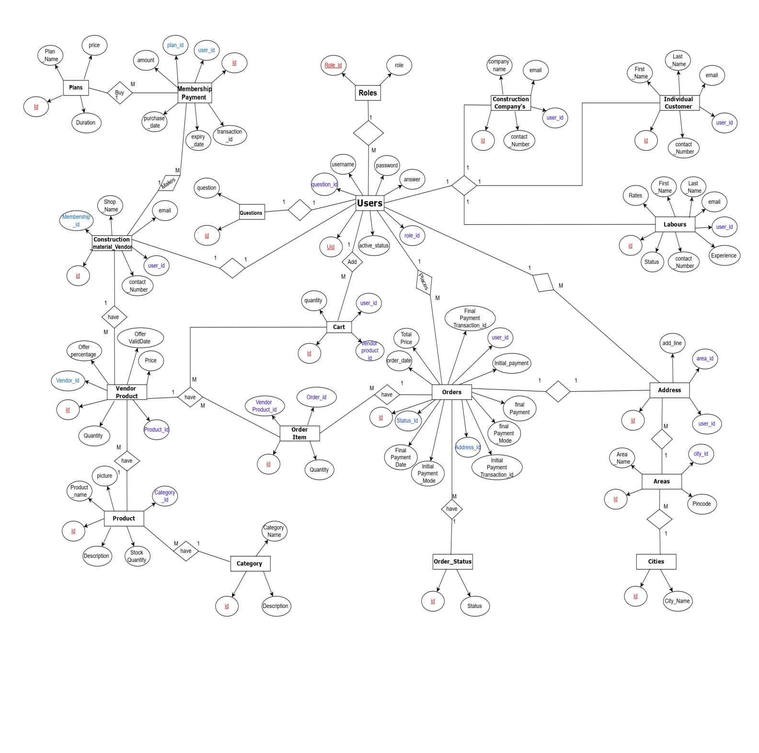

## 8.Page Navigation Diagram-

8.1 Page Navigation For Individual Customer

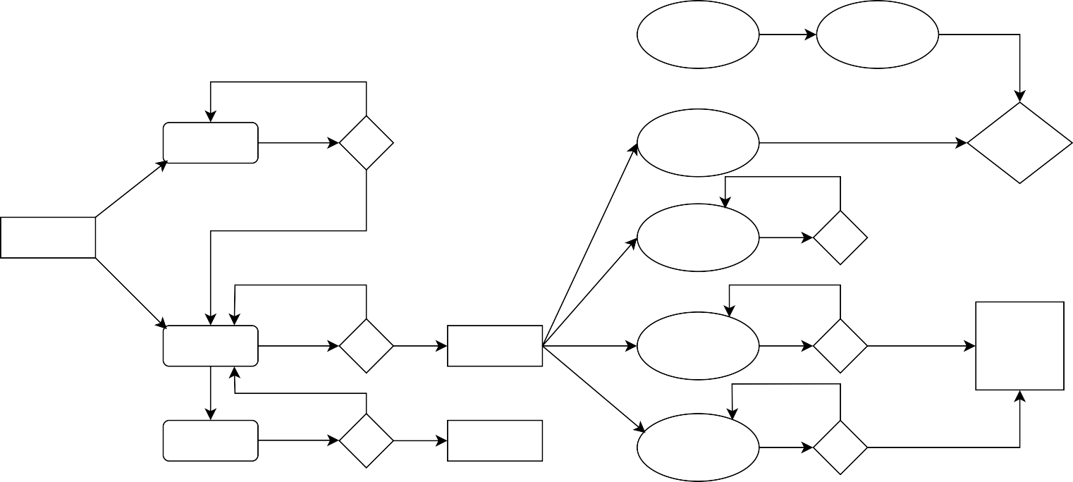

Search and View Product

Buy Product / Add to Cart

**N**

Register

View Cart

Make Payment?

**Y**

**N**

**Y**

**Y**

**Individual Customer**

View Order History

Order Placed

**N**

**N**

Login

**Y**

Customer Home Page

View Payment History

**Y**

Success

**Y**

**N**

Forgot Password

**N**

Error Page

View Profile

**Y**

**Y**

Logout

**N**

Fig Page Navigation For Individual Customer

8.2 Page Navigation For Construction Material Vendor:-

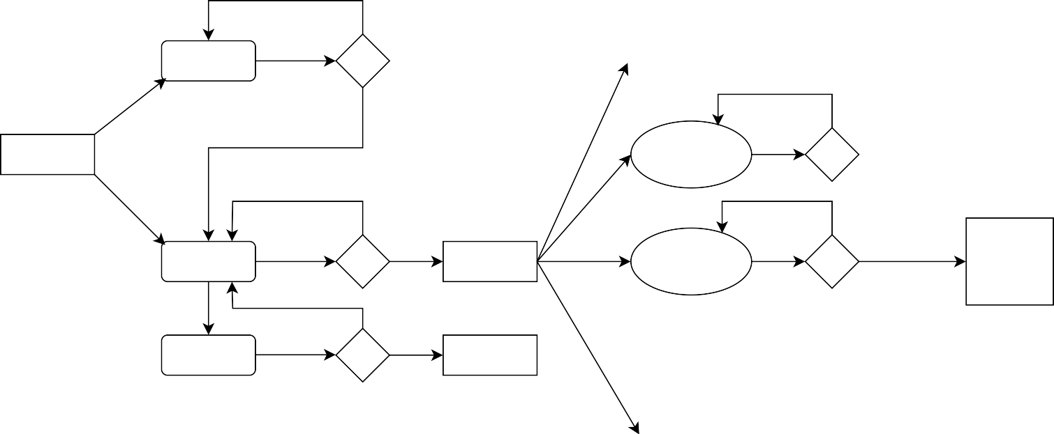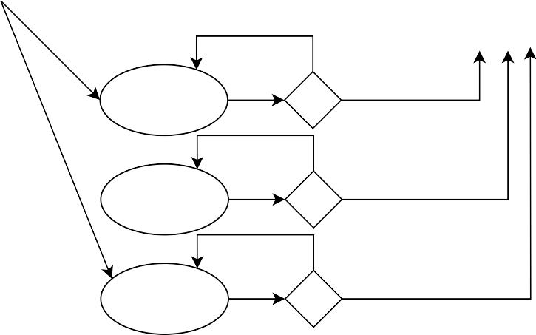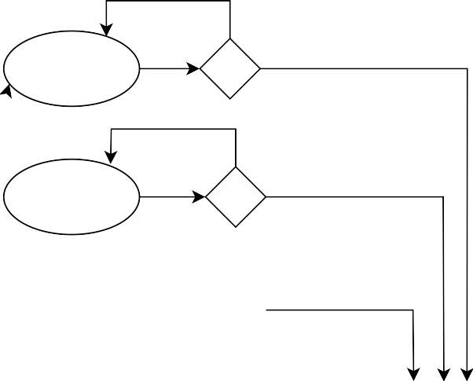

**N**

Add Product

**Y**

**N**

**N**

**Y**

Register

Delete Product

**Y**

**N**

**Y**

**Vendor**

Update Product Quantity & Rate

**N**

**N**

Login

**Y**

Vendor Home Page

View New Orders

**Y**

Success

**Y**

**N**

Forgot Password

**N**

Error Page

Update Order Status

**Y**

**N**

**Y**

View Order History

**N**

View

Payments

**Y**

Fig Page Navigation For Construction Material Vendor

**8.3** Page Navigation For Service Provider:-

Fig Page Navigation For Service Provider

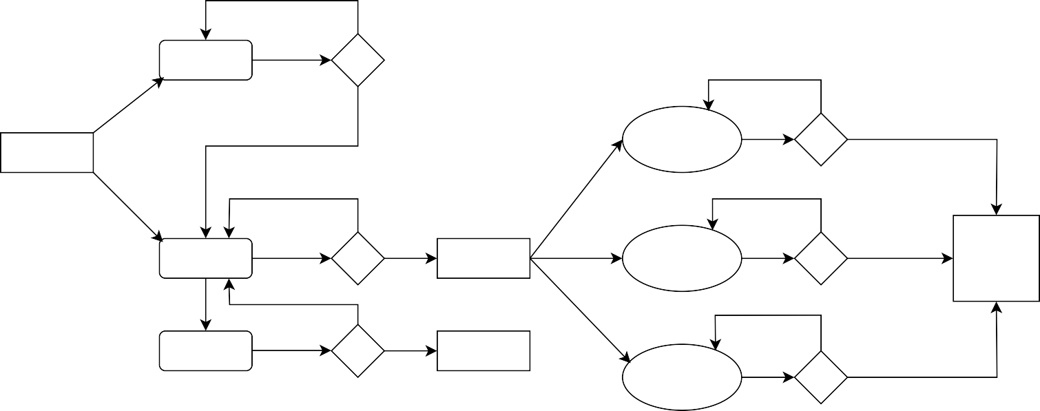

**N**

Register

**Y**

**N**

**Y**

**N**

**Service**

View Requests

**N**

**N**

Login

**Y**

Service Home Page

Update Availability Status

**Y**

Success

**Y**

Forgot Password

**N**

**N**

Error Page

**Y**

Update Rates

8.4 Page Navigation For Construction Company :-

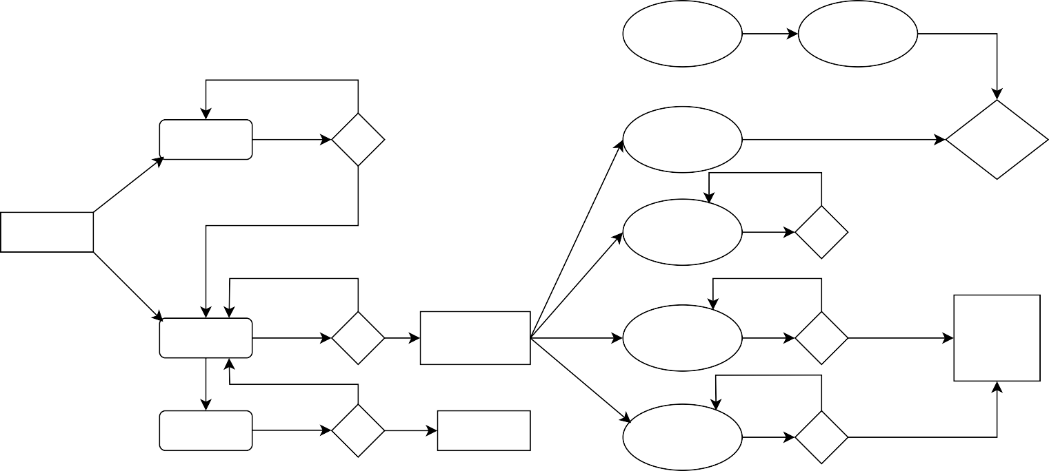

Search and

View Product

Buy Product / Add to Cart

**N**

Register

View Cart

Make Payment?

**Y**

**N**

**Y**

**Y**

**Construction Company**

View Order History

Order Placed

**N**

**N**

Login

**Y**

Const. Company Home Page

View Payment History

**Y**

Success

**Y**

**N**

Forgot Password

**N**

Error Page

View Profile

**Y**

**N**

Requesting To

Sp

**Y**

Logout

**N**

Fig Page Navigation For Construction Company

**8.5** Page Navigation For Admin:-

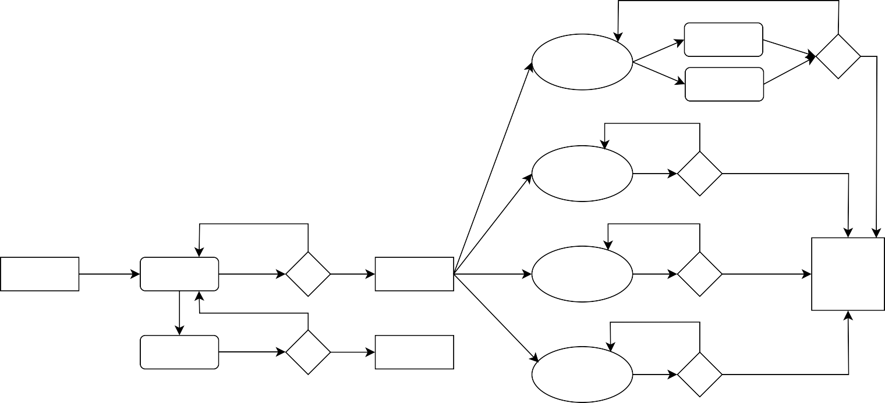

Accept

**N**

View New Request

Reject

**N**

Report Generation

**Y**

**N**

**N**

**Admin**

Login

**Y**

Admin Home Page

Membership Management

**Y**

Success

**Y**

Forgot Password

**N**

**N**

Error Page

Maintain

SP Status

**Y**

Fig Page Navigation For Admin

**9. Snapshots:**

**9.1 Home Page:**

Following snapshot shows the Home page for BuildMart before Login.

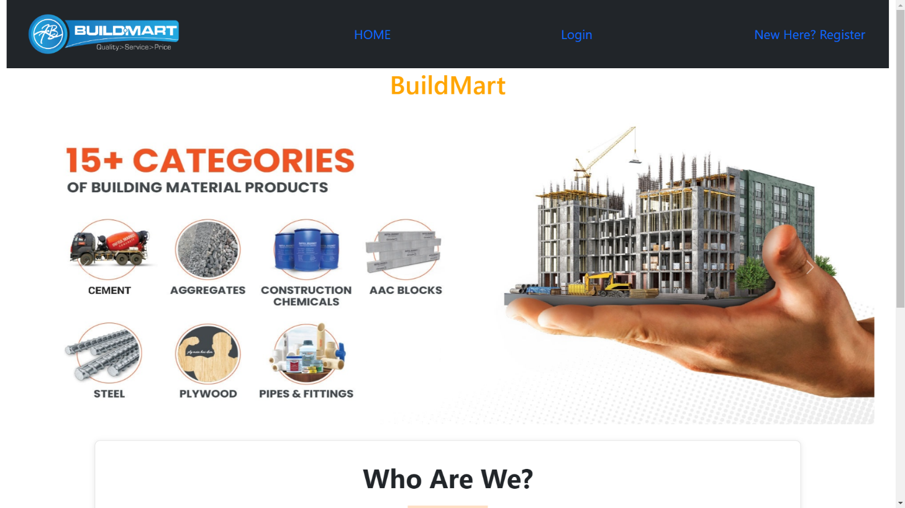

This page contains following controls

* Home
* Register
* Login Button

This page also contains footer consisting information about the website.

**9.2 Login Page**

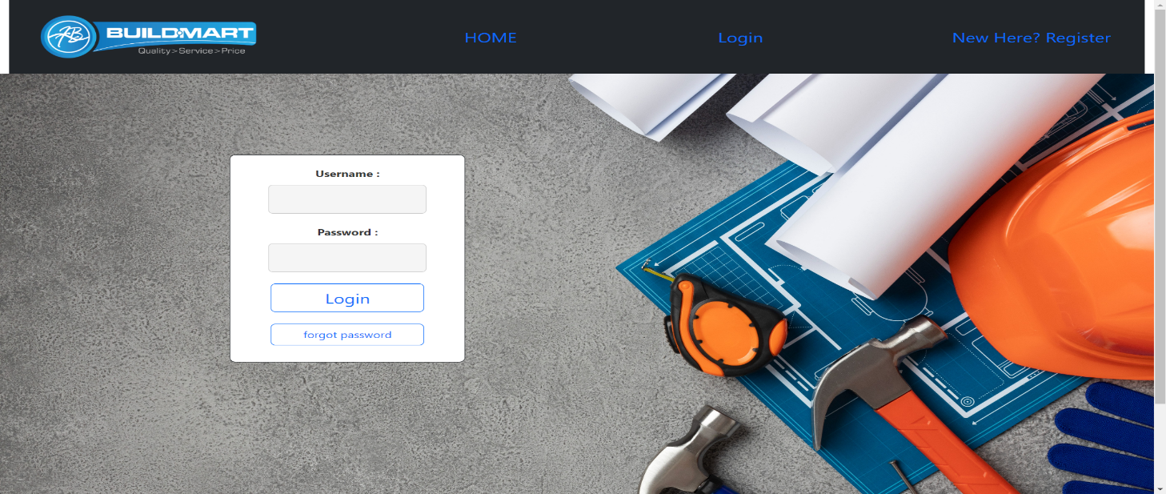

**9.3 Forgot password**

**9.4 Admin Home Page**

**9.4.1 List all Categories**

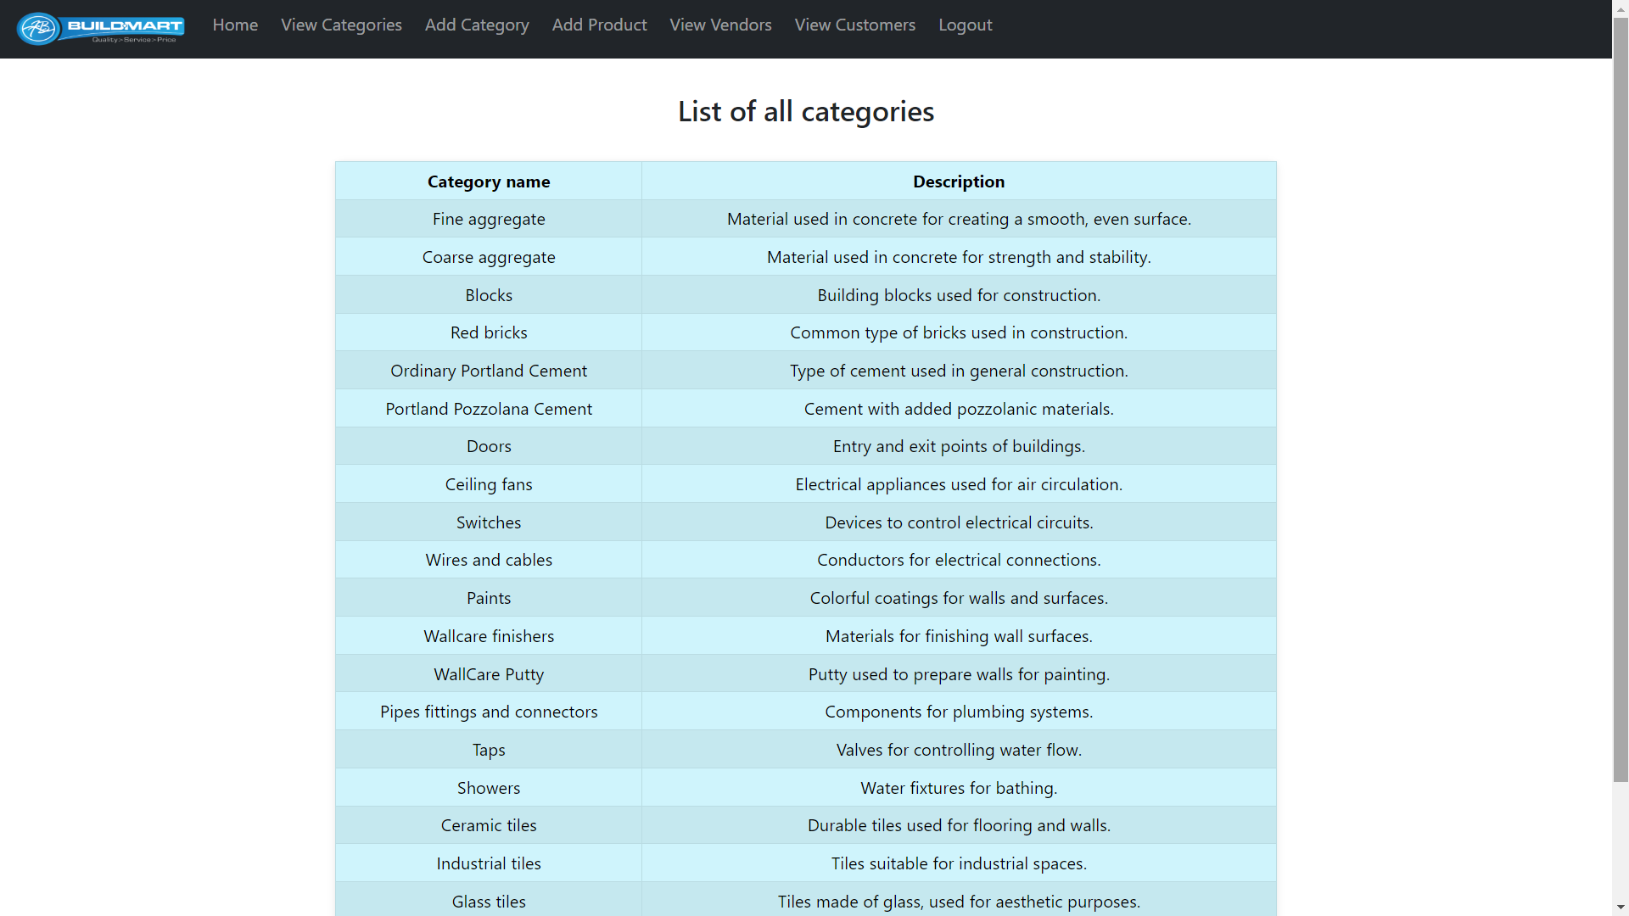

**9.4.2 Add New Category**

**9.4.3 List all Customers**

**9.4.3 List all Vendors**

**9.5 Customer**

**9.5.1 Customer Registration**

**8.5.2 Customer Home**

**8.5.3 View product**

**8.5.4 View Cart**

**8.5.4 Order Placed**

**9.6 Vendor**

**9.6.1 Vendor Home**

**9.6.1 Add new Product**

**9.6.1 Edit Product Details**

**10. CONCLUSION :-**

* BuildMart provides better platform to buy construction Materials easily ,economically and quickly.
* BuildMart provides comprehensive e-commerce platform for construction materials that caters to the needs of Individual customers, construction material vendor, and service providers, creating a thriving marketplace that facilitates seamless interactions and transactions within the construction industry.
* To solve the problems in traditional system and provide all the services at one place so that customer can easily avail the services